**Ideation Phase**

**Define the Problem Statements**

|  |  |
| --- | --- |
| Date | June 25, 2025 |
| Team ID | LTVIP2025TMID51580 |
| Project Name | visualizing housing market trends: an analysis of sale prices and features using tableau |
| Maximum Marks | 2 Marks |

**Customer Problem Statement Template:**

Create a problem statement to understand your customer's point of view. The Customer Problem Statement template helps you focus on what matters to create experiences people will love.

A well-articulated customer problem statement allows you and your team to find the ideal solution for the challenges your customers face. Throughout the process, you’ll also be able to empathize with your customers, which helps you better understand how they perceive your product or service.

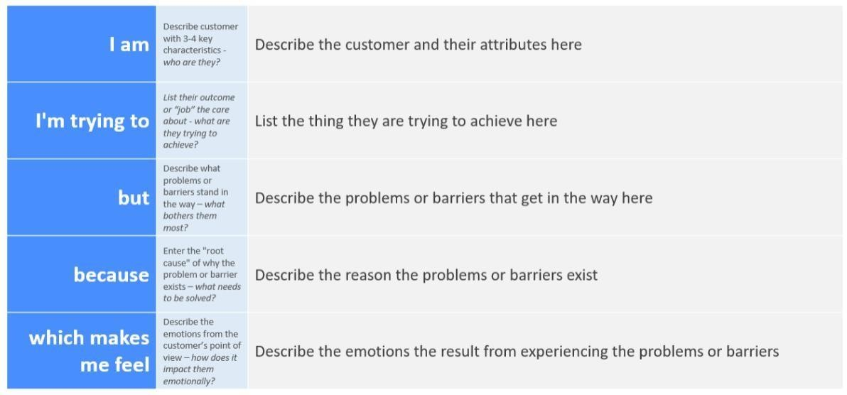

Reference: <https://miro.com/templates/customer-problem-statement/>**[E](https://miro.com/templates/customer-problem-statement/)xample:**



|  |  |  |  |  |  |
| --- | --- | --- | --- | --- | --- |
| **Problem**  **Statement**  **(PS)** | **I am**  **(Customer)** | **I’m trying to** | **But** | **Because** | **Which makes me**  **feel** |
| PS-1 | A first-time  homebuyer exploring housing options. | Understand what features  affect housing prices and identify affordable homes that meet my criteria. | The available data is scattered, difficult to interpret, and lacks visual clarity. | There is no unified platform or dashboard that simplifies housing data for easy comparison and decision making. | Confused,  overwhelmed, and uncertain about making a  high-stakes financial decision. |
| PS-2 | A real estate analyst working for an investment firm. | Identify housing market trends, outliers, and patterns in sale prices over time and across locations. | Traditional reports and spread sheets are time consuming to analyze and often miss insights hidden in large datasets. | There’s a lack of interactive tools that allow deep, dynamic exploration of the data. | Frustrated and inefficient in providing timely,  data-driven insights to stakeholders. |

2.2 EMpathy map

